Crypto Predictor Django Project Summary

# Introduction

This project is a Django-based web application that predicts cryptocurrency market signals based on user-provided input data. It utilizes a pre-trained machine learning model to predict whether the market signal is positive (📈) or negative (📉).

# Project Structure

The project follows a modular structure and includes the following key components:

* - `forms.py`: Defines the input form for collecting data from the user.
* - `predictor.py`: Contains the logic for loading the ML model and making predictions.
* - `views.py`: Handles HTTP requests and renders the result to the user.
* - `index.html`: The frontend template that collects inputs and displays results.

# Key Features

* - User-friendly UI for inputting cryptocurrency-related data.
* - Machine learning model integration for prediction.
* - Emoji-enhanced results for better user engagement (📈 Positive Go 😎🚀, 📉 Negative No 😕🔻).

# Technical Stack

* - Python 3.10
* - Django 5.2.3
* - HTML/CSS for frontend
* - Pickle for model serialization

# How It Works

1. The user accesses the homepage and submits a form with input data.  
2. Django's view handles the form submission, processes the input, and passes it to the `predict_crypto` function.  
3. The function loads the pre-trained model and predicts the outcome.  
4. The result (either positive or negative) is formatted with appropriate emojis and displayed on the frontend.

# Steps to Run through Anaconda Prompt :

1. (base) C:\Users\Mohammed Gouse>activate cryptoenv
2. (cryptoenv) C:\Users\Mohammed Gouse>d:
3. (cryptoenv) D:\>cd D:\Hope-AI\
4. (cryptoenv) D:\Hope-AI>cd D:\Hope-AI\09.3-Web Development-Detailed Way\01.Regression\Projects\crypto_predictor_django
5. (cryptoenv) D:\Hope-AI\09.3-Web Development-Detailed Way\01.Regression\Projects\crypto_predictor_django>python manage.py migrate
6. (cryptoenv) D:\Hope-AI\09.3-Web Development-Detailed Way\01.Regression\Projects\crypto_predictor_django>python manage.py runserver

Result : Starting development server at http://127.0.0.1:8000/

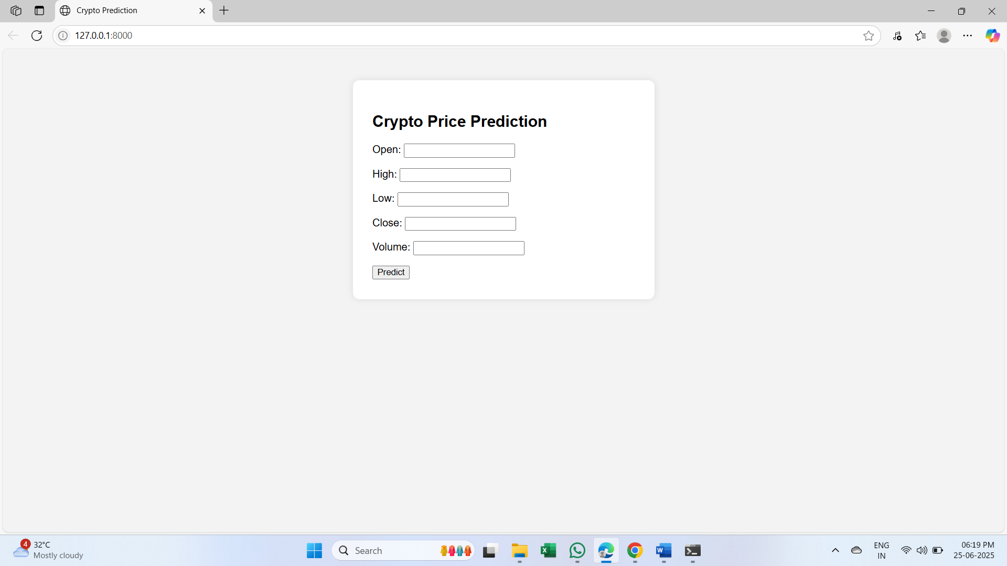

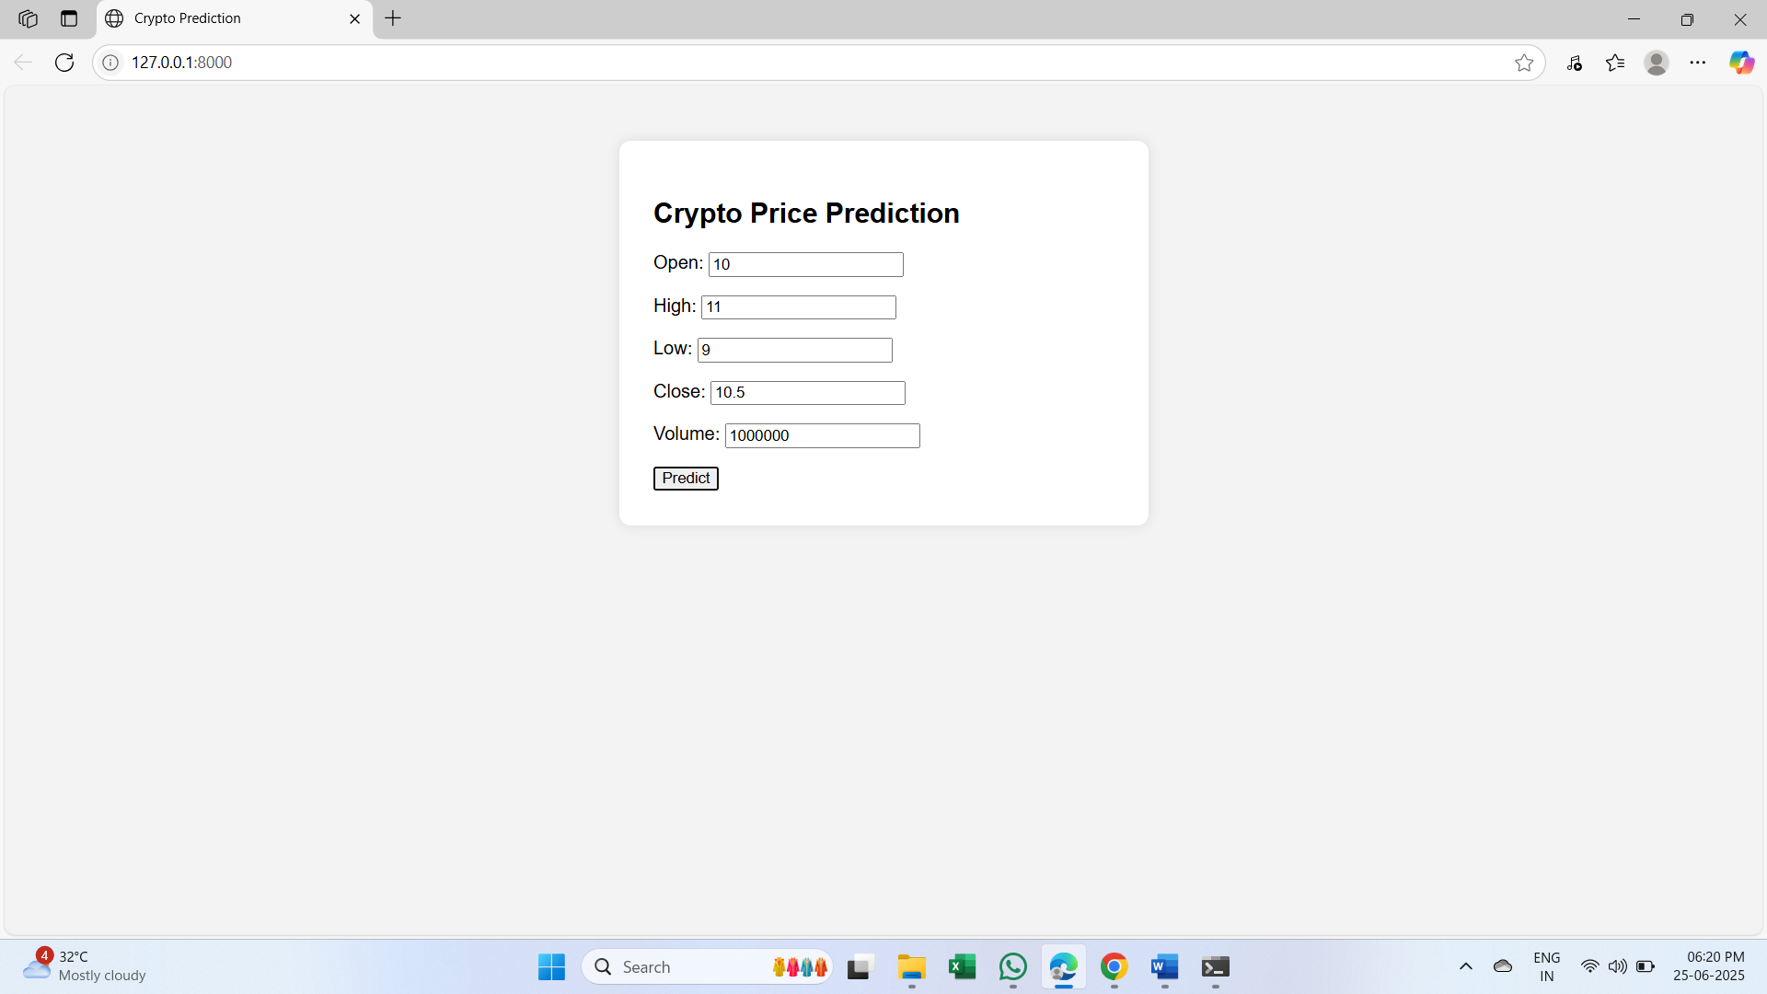

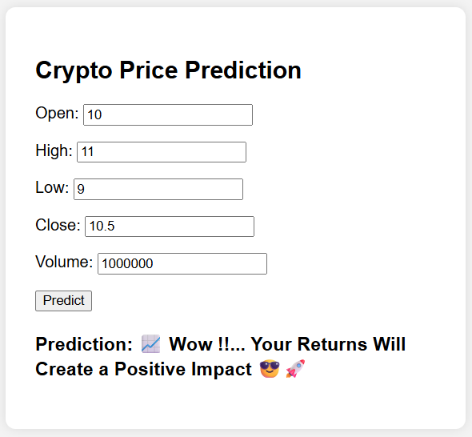

# Conclusion

The Crypto Predictor Django application offers a straightforward, interactive, and engaging way for users to explore machine learning predictions in the financial domain. Its clean design and fun UI make it accessible and enjoyable.

* **A Kind Proposal of Crypto Prediction from Mohammed Gouse. K**
* **by Thanking You 😊!!**